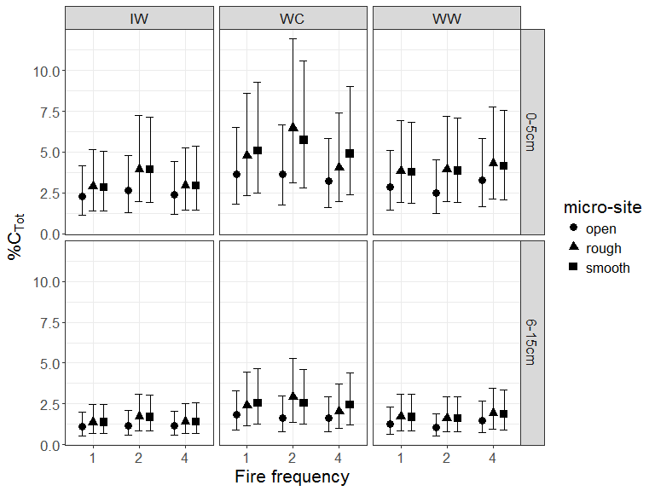

Figure 2. Predicted mean total % C (with upper and lower 95% confidence bounds) from ensemble modelling categorized by fire frequency, region and site characteristics. Fire frequency was represented as the number of fires (1,2,4) over 30 years prior to sampling 10 years post fire. Regions were characterized as: wet, cool (WC), annual precipitation 1200mm and annual average temperature 12◦C; wet, warm (WW) annual precipitation 1200mm, annual average temperature 16◦C; intermediate precipitation, warm (IW) annual precipitation 1000mm, annual average temperature 16◦C. Soil depth was characterized by two layers (0-5cm; 6-15cm). Micro sites sampled were: adjacent to base of rough barked trees (Rough); adjacent to base of smooth barked trees (Smooth); open patches largely between tree crowns (Open).